**Brain Tumor Classification**

**Capstone 2**

**Dawn Betzel**

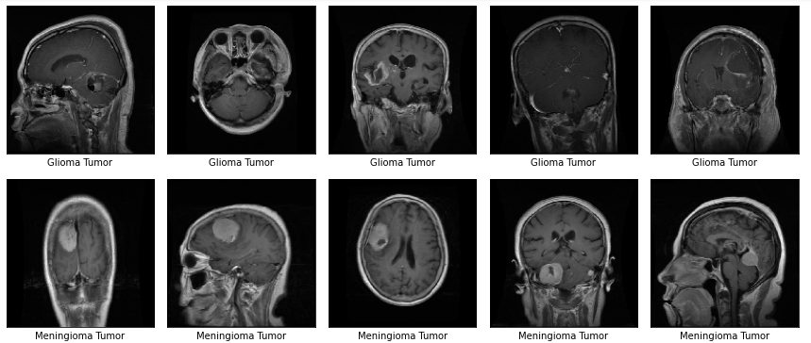

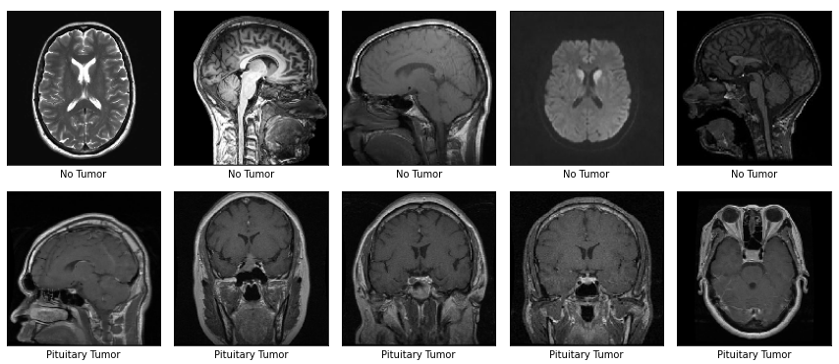

### 

### **Introduction**

A brain tumor is a mass or growth of abnormal cells in your brain. Many different types of brain tumors exist. Some brain tumors are noncancerous (benign), and some brain tumors are cancerous (malignant).

Symptoms of brain tumors vary according to the type of tumor and the location. Because different areas of the brain control different functions of the body, where the tumor lies affects the symptoms you get.

Some tumors have no symptoms until they’re large and then cause a serious, rapid decline in health. Other tumors may have symptoms that develop slowly.

Accurate diagnosis should be done for detecting brain tumors to start proper treatment early, so as to improve the life expectancy of the patient. The best technique to diagnose a brain tumor is Magnetic Resource Imaging (MRI).

# **Types of Brain Tumors for This Study**

#### Glioma is a type of tumor that occurs in the brain and spinal cord.

#### Pituitary is a tumor that forms in the pituitary gland near the brain that can cause changes in hormone levels in the body.

#### Meningioma is a tumor that forms on membranes that cover the brain and spinal cord just inside the skull.

No tumor is the best outcome diagnosis.

# **Data**

The data analyzed in this project was downloaded from <https://www.kaggle.com/sartajbhuvaji/brain-tumor-classification-mri>

The data consists of 3,264 files each of which contains an MRI image. The data was broken into Testing and Training. The data is broken into four different classifications: glioma_tumor, meningioma_tumor, no_tumor, and pituitary_tumor.

The data for no_tumor was taken from Navoneel Chakrabarty's kaggle dataset.[Link](https://www.kaggle.com/navoneel/brain-mri-images-for-brain-tumor-detection) While the remaining data was provided by Swati Kanchan [Link](https://github.com/Swati707/brain-tumor-classification/tree/master/Datasets). However, she made her repository private after sharing the data with us.

The data was unclean, the team did clean the data by manual examination of those images. (Eg. some images in 'no tumor' class clearly had tumors visible. ) Such images were deleted.

Finally, the team did approach a doctor who examined all the MRIs. He also provided a certificate for the cause of our project.

# **Abstract**

A Brain tumor is considered as one of the aggressive diseases, among children and adults. Brain tumors account for 85 to 90 percent of all primary Central Nervous System(CNS) tumors. Every year, around 11,700 people are diagnosed with a brain tumor. The 5-year survival rate for people with a cancerous brain or CNS tumor is approximately 34 percent for men and36 percent for women. Brain Tumors are classified as: Benign Tumor, Malignant Tumor, Pituitary Tumor, etc. Proper treatment, planning, and accurate diagnostics should be implemented to improve the life expectancy of the patients. The best technique to detect brain tumors is Magnetic Resonance Imaging (MRI). A huge amount of image data is generated through the scans. These images are examined by the radiologist. A manual examination can be error-prone due to the level of complexities involved in brain tumors and their properties.

Application of automated classification techniques using Machine Learning(ML) and Artificial Intelligence(AI)has consistently shown higher accuracy than manual classification. Hence, proposing a system performing detection and classification by using Deep Learning Algorithms using ConvolutionNeural Network (CNN), Artificial Neural Network (ANN), and TransferLearning (TL) would be helpful to doctors all around the world.

### **Context**

Brain Tumors are complex. There are a lot of abnormalities in the sizes and location of the brain tumor(s). This makes it really difficult to completely understand the nature of the tumor. Also, a professional Neurosurgeon is required for MRI analysis. Oftentimes in developing countries the lack of skillful doctors and lack of knowledge about tumors makes it really challenging and time-consuming to generate reports from MRI. So an automated system on the Cloud can solve this problem.

Also I happen to know from my recent work with a Radiology group, the doctors do share their datasets with AI / Machine Learning firms for research and future development in the imaging systems they use and to help the health of the world.

### **Definition**

To Detect and Classify Brain Tumor using CNN and Transfer Learning; as an asset of Deep Learning and to examine the tumor position(segmentation).

### **Data Wrangling**

You can see from the data section of this paper that the data set was as clean as the original authors could get it. They were even able to get a doctor to look it over and give it his best effort to clean. I only did a visualization to see all the different possibilities; five randomly selected glioma_tumor, meningioma_tumor, no_tumor and pituitary_tumor.

The images were already broken into Testing and Training datasets. I took each of the four classifications for each of the Training and Testing datasets and fed them into X_train, y_train, X_test, y_test respectively.

### **Preprocessing**

First I convert Training and Testing data to numpy arrays. Then I applied label encoding. Finally I used Keras flow_from_directory to change target to category.

### **Modelling**

The CNN model used several layers, RELU activation, max pooling, batch normalization, and a few dense layers using Keras Adam for optimization. This model performed alright with a 77% accuracy. It did very poorly on the glioma samples 41%, decent on the meningioma 80% and well on no tumor 83% and well on the pituitary 83%.

I then tried transfer learning at the recommendation of my mentor. The first model I attempted to use was the VGG19. It performed not much better than the CNN. The accuracy was slightly above 77%. The breakdown of this model’s accuracy by classification type was only 45% for glioma, only 79% for meningioma, much better at 89% for no tumor and 94% for pituitary.

Finally I ran another transfer learning using the Resnet model. This model performed just slightly better than the VGG19 had. It achieved an 82% overall accuracy. The breakdown for classification type was 54% for gioma, it did well with 82% for meningioma, continued to do well with 92% for no tumor (as VGG19 had), and did very well at 94% for pituitary.

**Conclusion**

All three models ran alright and had a lower than hoped for accuracy. All three models struggled the most with gioma classification. All three performed with a higher degree of accuracy on glioma and pituitary classifications, with the resnet model performing very well on the pituitary classification.